Lake Point Days 2022

Car show and Parade

<WWW.LAKEPOINTCOMMUNITY.COM/CAR-SHOW-PARADE>

Thank you for participating in our 2022 Lake Point Days Car Show and Parade! The car show will be held at Lake Point LDS Church parking lot from 10 AM until 3 PM on Saturday June 25th 2022. As part of your entry into the car show, you are also invited to drive down the parade route. Line up for the parade begins at 8 AM on Saturday at the corner of Mountain View and Sunset Rd in Lake Point. Please be in line no later than 8:45. If you choose not to participate in the parade, you need to be at the Lake Point LDS church by 8:45. Please email completed entry forms to [dan@lakepointins.com](mailto:dan@lakepointins.com). If you have any questions, please call 801-699-7099. We can’t wait to see your rides!

Name: ____________________________________________________

Phone #: __________________Email: ___________________________

Year: ____________Make: __________________

Model: _______________________Color: ________________________

Signature: __________________________ Date: __________

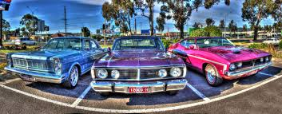

**Release of Liability:**  In consideration of the acceptance of the right to participate in the Lake Point Days Car Show, and Parade, participants and spectators, by execution of this form, release and discharge all promoters of the show: sponsors, State of Utah, Tooele County, Lake Points Parks and Cemetery District, Lake Point Community Association, Church of Jesus Christ of Latter Day Saints, their agents or employees, from any and all damages injuries, losses, judgments and/or claims whatsoever that may be suffered by any entrant to his/her person or property. I agree to abide by all rules and decisions made by show promoters and judges. Entrant agrees to clean up their own area after the show. Entrant understands and agrees that the Lake Point Days Show and events may be cancelled at its Organizers’ sole discretion due to inclement weather and other forces beyond the Organizers control. In the event of such a cancellation, Entrant acknowledges and understands that any and all funds and value provided by Entrant in sponsorship of the Lake Point Days Show, and Parade is nonrefundable and will not be returned in whole or in part to the Entrant.

**\*\*\*Participate at your own risk! LPCA and its volunteers are not liable or responsible in any way for the spread or transmission of COVID 19. By participating in this event, you agree not to hold LPCA, it’s vendors, volunteers or any associated members or participants of this event liable for any contamination that may occur. Face masks/coverings are optional, but not required.**

Lake Point Days 2022

Car show and Parade

Parade line up begins at 8 AM. Please check in at the corner of Mountain View and Sunset. Be in line before 8:45. For any parade questions call Annie Hullinger at 435-760-5113.

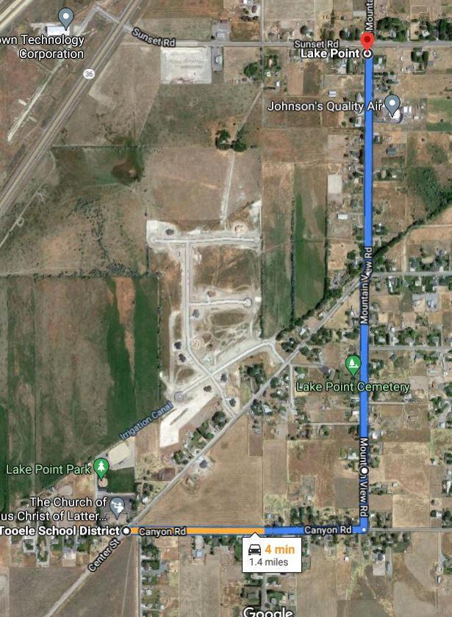

Parade will begin at the intersection of Sunset Road and Mountain View Road.

Parade route ends at the intersection of Canyon Road and Center Street; proceed to The Lake Point Park!

Participants have the chance at leaving with **remarkeable**  trophies!!

